ECCR 2022 – Practical information

Address:
Råbjerg Mile Camping
Kandestedvej 55
DK – 9990 Skagen
Phone: +45 9848 7500
Mail: info@raabjergmilecamping.dk
www.raabjergmilecamping.dk

Directions:
Take highroad E45 north against Frederikshavn. Follow the road through Frederikshavn and follow road 40 against Skagen. Råbjerg Mile Campsite is placed 14 kilometers south of Skagen.

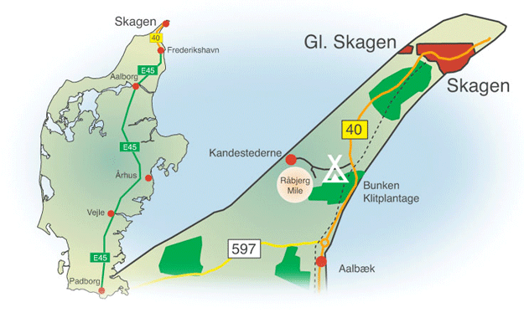

When:

Thursday the 23th of June to the 26th of June 2022.

At arrival you will be shown your place a the campsite and you will receive a welcome packet with information about ECCR, the campsite and Skagen.

Prices:
The price includes 3 nights (power and all the facilities on the campsite are included). Welcome drinks Thursday and Galla dinner with live music Saturday is also included.

For caravan and 1. person 140€
For caravan and 2 persons 190€
For caravan and 3 persons 240€ etc.

Registration and payment:
Deadline for registration and payment is the 1th of March.
Please see: www.veterancamping.dk

The camsite offers:
- Well maintained service buildings. Here you will find toilets and bathrooms.
- Nice functional kitchen and grill facilities.
- Minimarket – Where you can buy freshly baked bread, pizza, burgers, icecream and groceries.
- Outdoor and indoor pool, sauna and hot tub.
- Playground, minigolf, tennis, tabletennis.
- Bike rentals
- Dog are allowed

If you wish to arrive earlier or extend our stay, you can contact the Campsite with our request. The cost per day is 23€ per caravan (power included).

